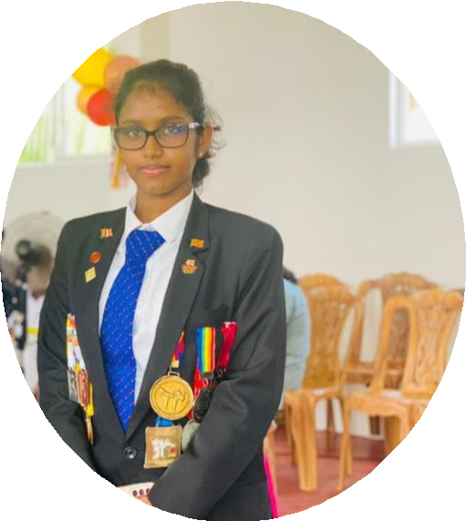

**National Black Belt Rank of 3rd Dan**

# CONTACT

+94 770153270

[nethunavo24@gmail.com](mailto:nethunavo24@gmail.com)

# EDUCATION

* BSc (Hons)Software Engineering (Plymouth – United Kingdom)

## Second Year

* English Language Skills for Employment

The Department of Language University of Moratuwa **Credit Pass**

# SKILLS

* + Project Management
  + Teamwork
  + Leadership
  + Effective Communication
  + Critical Thinking

NAVODYA JAYAMANI

# EXTRACURRICULAR

* G-man Shotokan Open Karate Championship 2015
* Kalutara District Championship 2016
* Western Province Karate championship 2017
* 15th WKI International Karate Championship 2017
* SHINBUKAN CUP International Open Karate Championship 2018
* Western Province Karate Championship 2018

## National Karate Championship 2018

* G-man Shotokan Open Karate Championship 2018
* Western Province Karate Championship 2019
* International Open Karate Championship 2019

## Ambassador Of Japan Karate Championship 2020

* Inter House Sports & Athletic Meet Kalutara Balika Vidyalaya 2016,2017,2018,2019 & 2020
* 46th National Sports Festival Inter Divisional Secretariat 2020
* Best Player in Karate 2020 – Kalutara Balika Vidyalaya

## National Karate Championship 2021

* Global Virtual Karate Championship 2021
* Nippon Karate Championship 2022
* 47th National Sports Festival Inter Divisional Secretariat 2022
* Kensho Karate International 25th Open Karate Championship 2023
* Sports Fiesta 2024
* National Karate Championship (Western Province) 2024
* Kensho Karate International 26th Open Karate Championship 2024
* 48th National Sports Festival Inter Divisional Secretariat 2024

## National Karate Championship 2024

* Best Player in Karate 2024 – NSBM Green University

# EXPERIENCE

Sri Lanka Karate Do Federation -Karate Instructor